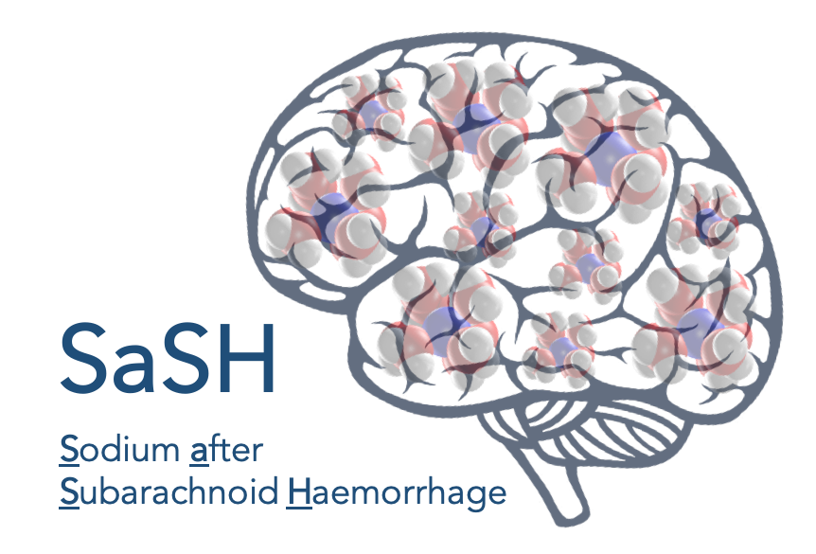

Sodium after Subarachnoid Haemorrhage (SaSH) Audit: neurosurgical trainees

What?
This audit will evaluate whether current UK management of patients following spontaneous sub-arachnoid hemorrhage (SAH) adheres to European Stroke Organisation guidelines for electrolyte monitoring after SAH and the European Society of Endocrinology guidelines for investigation of hyponatremia.

Why?
Despite being the most commonly detected electrolyte abnormality occurring in SAH patients, no national guidelines have been developed to directly address the management of hyponatremia following SAH.

Furthermore, the specific impact of hyponatremia on SAH outcomes has not yet been defined, due to inconsistency and bias across studies. This audit seeks to establish a national baseline through a UK-wide, hospital-based audit of screening, investigation, and management of hyponatremia following SAH.
This is an excellent opportunity to become involved in a UK wide audit and all collaborators will receive collaborator status – indexed on PubMed - on publications arising from this work.

Who?
Any neurosurgical trainee or registrar who would like an opportunity to be involved in a large-scale national audit as a local trainee lead. Must be able to undertake or supervise local medical students with data collection at their local neurosurgical unit. Local clinical and information governance approval must be obtained prior to data collection and it is expected that local trainee leads would take responsibility for this.

When?
Data collection will occur at neurosurgical units over a site-selected two-month period between 1st September 2019 – 29th February 2020.

How do I get involved?
Register your details and neurosurgical unit for participation at: https://forms.gle/YMkpcjNzrkedKNQ86

Medical students and non-neurosurgical doctors can register at: https://forms.gle/Z9rfbasrXEJyP4569

Information on applying can be found by contacting either:
James Loan Edinburgh (ECAT clinical lecturer in neurosurgery) James.loan@ed.ac.uk
Steven Tominey Edinburgh (medical student liaison) tomineys@nsamr.ac.uk

